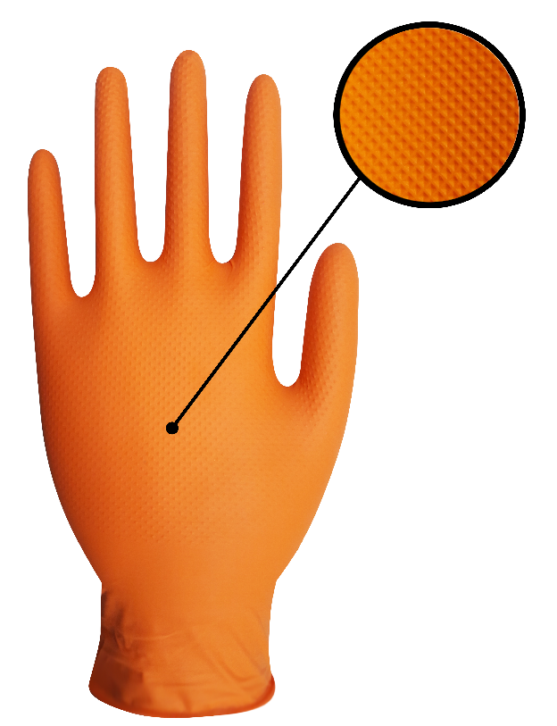**ULTIMATE GRIP PRODUCT SPECIFICATIONS**

**Name of Product** - 7 Mil Ultimate Grip Gloves.

**Name of Manufacturer**  - Innovative Gloves Co. Ltd. Hatyai, Thailand.

**Base Material**  - Nitrile.

**Characteristics** -Non-Sterile, Ambidextrous.

**Available Sizes** - Small, Medium, Large, X-Large, XX-Large.

**Surface** - Diamond Textured.

**Surface Treatment** - Polymer Coated.

**Color**  - Orange.

**Total Residue Content** - < 2.0 Milligrams per glove.

**Physical Specifications:**

|  |  |  |  |  |  |  |  |
| --- | --- | --- | --- | --- | --- | --- | --- |
| **Size** | **Length(mm/inch)** |  | | **Thickness(mm)**  **Single Wall** | | | **Width(mm)** |
| Tip Smooth Surface | Tip Textured Surface | | Palm | Cuff |
| Small | 240±5 | 0.19±0.01 | 0.28±0.02 | | 0.23±0.02 | 0.11±0.01 | 85±5 |
| Medium | 240±5 | 0.19±0.01 | 0.28±0.02 | | 0.23±0.02 | 0.11±0.01 | 95±5 |
| Large | 240±5 | 0.19±0.01 | 0.28±0.02 | | 0.23±0.02 | 0.11±0.01 | 105±5 |
| X-Large | 240±5 | 0.19±0.01 | 0.28±0.02 | | 0.23±0.02 | 0.11±0.01 | 115±5 |
| XX-Large | 240±5 | 0.19±0.01 | 0.28±0.02 | | 0.23±0.02 | 0.11±0.01 | 120±3 |

**Tensile (ASTM D412 & EN 455-2)**

**Before Aging**

|  |  |  |
| --- | --- | --- |
| **Tensile(MPA)** | **Elongation(%)** | **Force At Break(N)** |
| 22 Mpa Min. | 500 Min. | ≥ 6 N |

**After Accelerated Aging**

|  |  |  |
| --- | --- | --- |
| **Tensile(MPA)** | **Elongation(%)** | **Force At Break(N)** |
| 22 Mpa Min. | 400 Min. | ≥ 6 N |

**Packaging**

|  |  |
| --- | --- |
| **Packaging (Normal)** | 100±2 pieces in one Dispenser Box,10 Dispenser Box in one Carton. |
| **Labeling on Dispenser (Normal)** | Product Name, Size, Lot no. Quantity, Manufacturer’s address. |
| **Labeling on Carton (Normal)** | Product Name, Size, Lot no. Quantity, Country of Origin. |

**Container Loadability** (No MOQ in manufacturer owned brand in standard Packaging)

|  |  |
| --- | --- |
| 20 FCL=910 Cartons. | 40 FCL=1840 Cartons. |

,

**Certification**

A picture containing object

Description generated with high confidence